PART I: Build, Train, and Test a Simple RNN on Sine Wave Data (70 Points)
SUBMISSION REQUIREMENT #1
--) Submit a Jupyter Notebook document (in its native format, not PDF) that shows coding all the steps and the results of each step while redoing the project.
Answer:
The jupyter notebook is submitted as part of this assignment with the code and execution result of each step.

PART II: Write the Project Report (30 Points)
SUBMISSION REQUIREMENT #2:
--) Submit the report in an MS Word document.
Answer:
Report: Build, Train, and Test a Simple RNN on Sine Wave Data
Objective: To build, train and test a simple recurrent neural network on sine wave data.
Steps:
- Importing libraries:
  - The required libraries were imported to successfully build the RNN
    - timeseries RNN neural network
    - basic libraries
    - keras: TimeseriesGenerator
    - keras: MinMax scalar
- Data Generation:
  - Used numpy to create a simple sine wave
  - Plotted the sine wave
  - Loaded it into a pandas dataframe
- Split Train and Test Data:
  - The data is split into training and testing with test data set having 20% of the data.
  - The test dataset has a total 205 records.
  - The test start index is 815.
- Normalize the data:
  - We have used MinMaxScalar.
  - We are scaling only the training data. We are not scaling the testing data
  - Then we transform both training data and testing data.
- Create time series generator instance:
  - Set the length of the input sequence as 50.
  - Batch size as 1.
  - Use the TimeseriesGenerator method to create the time series.
  - This produces time series batches used to train the model.
- Build and Test Model:
  - The dataset has only one attribute: Sine values of index x. So only one feature is used to train the model.
  - Define the model
  - Add a simple RNN layer with 100 neurons.
  - One neuron for each input data point.
  - Add a fully connected layer for the final prediction with only one neuron.
- Compile the Model:
  - Use model.compile to compile the model.
  - The model summary is printed and shown in the below table.
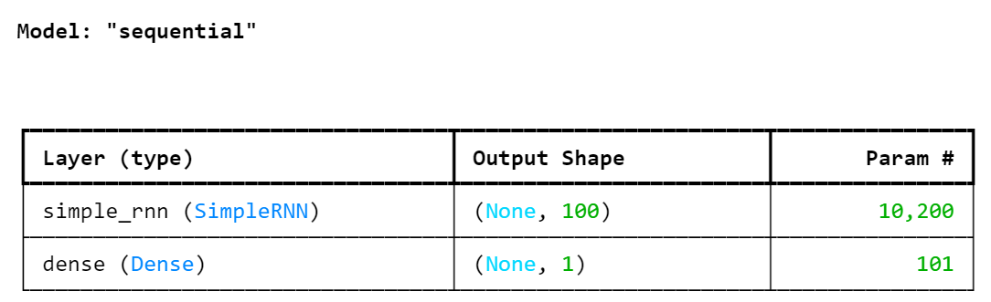
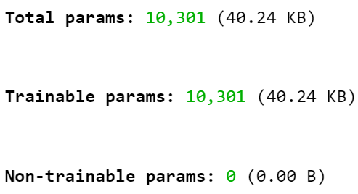
- Train the Model:
  - Fit the model using model.fit()/ model.fit_generator()
- Visualize model performance after training:
  - Load the loss data into a dataframe and plot it.
  - The figure below displays the plot.
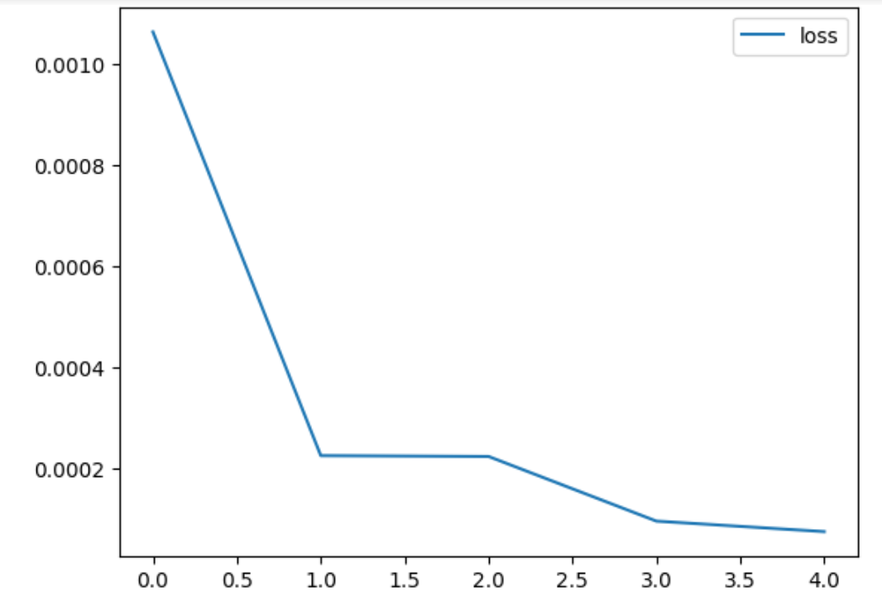
- Evaluate Model’s performance on Tests Data
  - Store the predictions in a separate list
  - Make predictions for each batch and append it in the list.
- Revert the scaled values back to real values
  - Use inverse transform to revert the scaled values to real values.
- Append the predictions list to the dataframe
  - Visualize the predicted sine wave and the original sine wave.
  - The below figure shows the same.
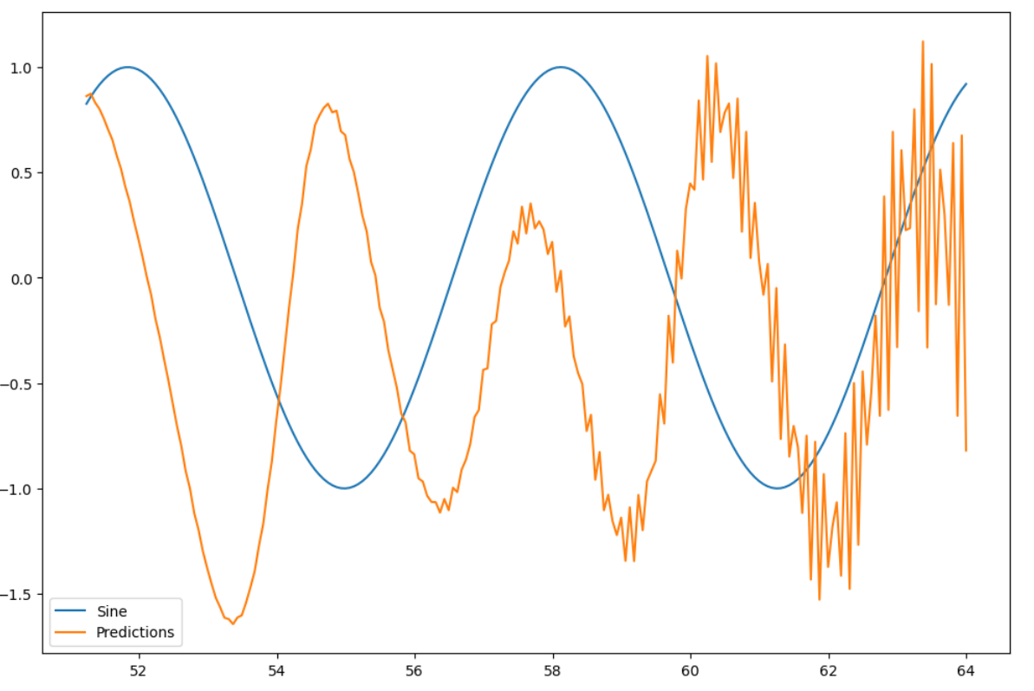
Conclusion: In this assignment we successfully created dataframe for a sine wave, split the generated dataset into training and testing dataset. We also normalized the data, built the model with adding hundred RNNs and trained the model, visualized the model’s performance and predicted the data. We also plotted the predicted and original data to understand the model’s performance.
Note:
- The jupyter notebook is having this code is uploaded as part of this assignment.
- The below code is deprecated. I have used an alternate code.
- Given Code: #model.fit_generator(train_tsGenerator50, epochs=5)
- Alternate code: model.fit(train_tsGenerator50,epochs=5 )

